

Practical File Submission

Course Name: JavaScript Lab
Course Code: T-3013 / 0705210508
Submitted by
Sanvi Wadhankar
24070521191
Batch: 2024-28
Semester - V
Section: C

Submitted to
Dr. Shreyas Rajendra Hole

Practical 1
Experiment Title: Demonstrate inline, internal, and external JavaScript; use console methods; create a webpage showing user info and a welcome message.
Software/Tools Required: VS Code , Web Browser
Experiment Program Code:
Demo html file:
<!DOCTYPE html>
<html>
<head>
<title>JS Demo</title>
<style>
body {
background-color: #eef3ff;
font-family: Arial, sans-serif;
text-align: center;
padding: 40px;
}

h1 {
color: #1a5cff;
}
button {
background-color: #1a5cff;

color: white;
border: none;
padding: 10px 18px;
margin: 6px;
border-radius: 6px;
font-size: 15px;
cursor: pointer;
}

button:hover {
background-color: #0d3fb0;
}

#output {
margin-top: 20px;
font-size: 16px;
color: #333;
}
</style>
</head>
<body>

<h1>Welcome to my Webpage!</h1>
<p id="output"></p>

<!-- INLINE JS -->

<button onclick="console.log('Inline JS: Button clicked!')">Inline JS</button>

<!-- INTERNAL JS -->
<button id="internalBtn">Internal JS</button>

<!-- EXTERNAL JS -->
<button id="externalBtn">External JS</button>

<script>
// INTERNAL JS - shows welcome message and logs it
document.getElementById("output").innerText = "Welcome! Today's date is " + new Date().toDateString();
console.log("Internal JS: Page loaded, welcome message shown.");

document.getElementById("internalBtn").onclick = function () {
console.log("Internal JS: Browser - " + navigator.userAgent);
console.log("Internal JS: Platform - " + navigator.platform);
};
</script>
<script src="script.js"></script>

</body>
</html>

Output:
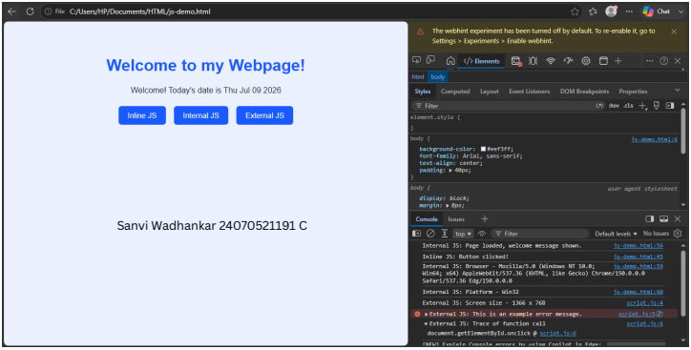

Case Study 01
Case Study Title:- Create a web page for college department and link the student information page with it and write a js program to display "Welcome to SIT Nagpur" in an alert box
Case Study Code:
Department file (HTML):-
<!DOCTYPE html>
<html>
<head>
<title>Department Home</title>
<style>
body {
background-color: #f5f8ff;
font-family: Arial, sans-serif;

margin: 0;
padding: 0;
}
header {
background-color: #1a5cff;
color: white;
padding: 20px;
text-align: center;
}
header h1 {
margin: 0;
font-size: 26px;
}
header p {
margin: 5px 0 0;
font-size: 14px;
}
.content {
max-width: 500px;
margin: 30px auto;
background-color: white;
padding: 25px;
border-radius: 8px;
border: 1px solid #ddd;
text-align: center;
}
.content h2 {
color: #1a5cff;
cursor: pointer;
}

.content p {
color: #444;
line-height: 1.6;
}
a.btn {
display: inline-block;
margin-top: 10px;
background-color: #1a5cff;
color: white;
text-decoration: none;
padding: 8px 16px;
border-radius: 5px;
font-size: 14px;
}
a.btn:hover {
background-color: #0d3fb0;
}
footer {
text-align: center;
color: #888;
font-size: 12px;
margin: 30px 0 10px;
}
</style>
</head>
<body>
<header>
<h1>SIT Nagpur</h1>
<p>Department of Computer Science</p>
</header>

<div class="content">
<!-- INLINE JS -->

<h2 onclick="console.log('Inline JS: Department title clicked!')">
Welcome to our Department Page
</h2>
<p>Click the heading above to see an inline JS console message. This page also links to the student information page below.</p>
<a class="btn" href="student-info.html">View Student Information</a>
</div>
<footer>Made by a Student &middot; SIT Nagpur</footer>
<script>
// INTERNAL JS
console.log("Internal JS: Department page loaded successfully.");
</script>
<!-- EXTERNAL JS -->
<script src="script.js"></script>
</body>
</html>
Student Info (html):-
<!DOCTYPE html>
<html>
<head>
<title>Student Information</title>
<style>
body {
background-color: #f5f8ff;
font-family: Arial, sans-serif;
margin: 0;
padding: 0;
}
header {
background-color: #1a5cff;

color: white;
padding: 20px;
text-align: center;
}
header h1 {
margin: 0;
font-size: 24px;
}
.content {
max-width: 500px;
margin: 30px auto;
background-color: white;
padding: 25px;
border-radius: 8px;
border: 1px solid #ddd;
text-align: center;
}
table {
margin: 15px auto;
border-collapse: collapse;
width: 100%;
}
td, th {
border: 1px solid #ddd;
padding: 8px 12px;
font-size: 14px;
}
th {
background-color: #eef3ff;
color: #1a5cff;

}

a.btn {
display: inline-block;
margin-top: 15px;
background-color: #1a5cff;
color: white;
text-decoration: none;
padding: 8px 16px;
border-radius: 5px;
font-size: 14px;
}
a.btn:hover {
background-color: #0d3fb0;
}
footer {
text-align: center;
color: #888;
font-size: 12px;
margin: 30px 0 10px;
}
</style>
</head>
<body>
<header>
<h1>Student Information</h1>
</header>

<div class="content">
<table>
<tr>
<th>Name</th>
<th>Roll No.</th>
<th>Branch</th>
</tr>
<tr>
<td>Your Name</td>
<td>101</td>
<td>Computer Science</td>
</tr>
</table>

<a class="btn" href="department.html">Back to Department Home</a>
</div>

<footer>Made by a Student &middot; SIT Nagpur</footer>
<script>
// INTERNAL JS
console.log("Internal JS: Student information page loaded.");
</script>
</body>
</html>

Output:

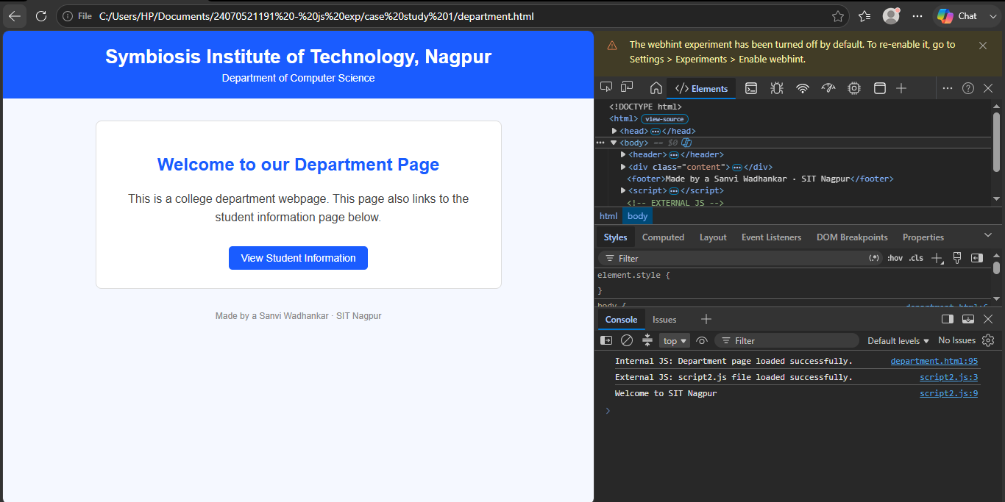
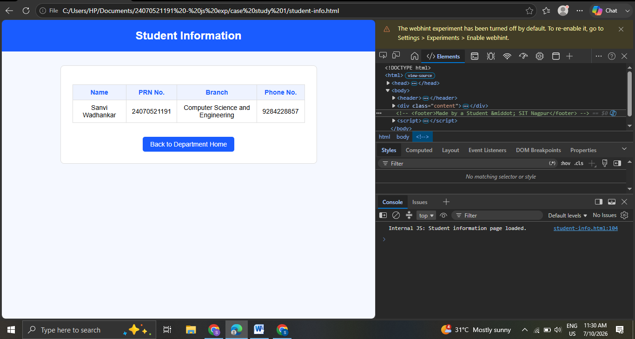

Result / Conclusion:-
Hence we have created a basic html page with javascript to show student information and and website login page.

Practical 02
Aim:- Use var, let, const, and demonstrate basic features like template literals and destructuring; build a billing calculator with user input.
Software/Tools Required: VS Code , Web Browser
Experiment program code:
Calculator.html:-
// Use var, let, const, and demonstrate basic features like template literals and destructuring; build a billing calculator with user input.
<!DOCTYPE html>
<html>
<head>
<title>Billing Calculator</title>
</head>
<body>
<h2>Billing Calculator</h2>

<script>
// const example
const GST = 0.18;

//user Input
var customerName = prompt("Enter Customer Name:");
var productName = prompt("Enter Product Name:");

// var example
var quantity = Number(prompt("Enter Quantity:"));
let price = Number(prompt("Enter Price per Item:"));

//Calculations
let total = quantity * price;
let gstAmount = total * GST;
let finalBill = total + gstAmount;

//Object
const bill = {
customer: customerName,
product: productName,
quantity,
price,
total,
gstAmount,
finalBill
};

//Destructuring
const {
customer,
product,
gstAmount: gst,
finalBill: amountz
} = bill;

//Output using Template Literals
document.write(`<h3>Billing Receipt</h3>`);
document.write(`<p>Customer: ${customer}</p>`);
document.write(`<p>product: ${product}</p>`);
document.write(`<p>Quantity: ${quantity}</p>`);
document.write(`<p>Price per Item: ₹${price}</p>`);
document.write(`<p>GST (18%): ₹${gst.toFixed(2)}</p>`);
document.write(`<p>Final Bill: ₹${amount.toFixed(2)}</p>`);

</script>
</body>
</html>

Output:-
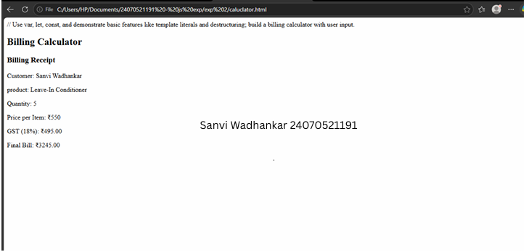
Case Study 02
Case Study Title:- Develop the webpage for an online shopping website with using HTML,CSS and HTML5 tags
Software/Tools Used:- VScode , Web Browser
Code:-
<!DOCTYPE html>
<html>
<head>
<title>Online Shopping - Bill Calculator</title>
</head>
<body>

<h1>Online Shopping Store - Bill Calculator</h1>

<form id="billForm">

<label for="custName">Customer Name</label><br>
<input type="text" id="custName" required><br><br>

<label for="mobile">Mobile Number</label><br>
<input type="tel" id="mobile" required><br><br>

<label for="invoice">Invoice Number</label><br>
<input type="text" id="invoice" required><br><br>

<label for="product">Product Name</label><br>
<input type="text" id="product" required><br><br>

<label for="quantity">Quantity (in Kg)</label><br>
<input type="number" id="quantity" step="0.1" required><br><br>

<label for="rate">Rate per Kg (Rs.)</label><br>
<input type="number" id="rate" step="0.01" required><br><br>

<label for="discount">Discount (%)</label><br>
<input type="number" id="discount" step="0.1" value="0"><br><br>

<label for="gst">GST (%)</label><br>
<input type="number" id="gst" step="0.1" value="0"><br><br>

<label for="packing">Packing Charges (Rs.)</label><br>
<input type="number" id="packing" step="0.01" value="0"><br><br>

<label for="payment">Payment Mode</label><br>
<select id="payment">
<option value="Cash">Cash</option>
<option value="Card">Card</option>
<option value="UPI">UPI</option>
</select><br><br>

<label for="membership">Membership</label><br>
<select id="membership">
<option value="No">No</option>
<option value="Yes">Yes</option>
</select><br><br>

<button type="button" onclick="calculateBill()">Calculate Bill</button>
</form>

<div id="result"></div>

<script>
// INTERNAL JS (inbuilt script inside the HTML file)

function calculateBill() {
// Reading input values - all inputs return strings, so we convert them
// using Number() to demonstrate type conversion
let custName = document.getElementById("custName").value; // string
let mobile = document.getElementById("mobile").value; // string
let invoice = document.getElementById("invoice").value; // string
let product = document.getElementById("product").value; // string

let quantity = Number(document.getElementById("quantity").value); // number
let rate = Number(document.getElementById("rate").value); // number
let discount = Number(document.getElementById("discount").value); // number
let gst = Number(document.getElementById("gst").value); // number
let packing = Number(document.getElementById("packing").value); // number

let payment = document.getElementById("payment").value; // string
let membership = document.getElementById("membership").value === "Yes"; // boolean

// Basic validation
if (!custName || !mobile || !invoice || !product || quantity <= 0 || rate <= 0) {
console.error("Validation failed: Please fill all required fields correctly.");
alert("Please fill all required fields with valid values.");
return;
}

// Calculation
const subtotal = quantity * rate;
const discountAmount = (subtotal * discount) / 100;
const afterDiscount = subtotal - discountAmount;
const gstAmount = (afterDiscount * gst) / 100;

// Extra membership discount (const used since this value won't change)
const membershipDiscount = membership ? afterDiscount * 0.05 : 0;

let totalBill = afterDiscount + gstAmount + packing - membershipDiscount;

console.log("----- Bill Calculation -----");
console.log("Customer: " + custName);
console.log("Subtotal: Rs. " + subtotal.toFixed(2));
console.log("Discount Amount: Rs. " + discountAmount.toFixed(2));
console.log("GST Amount: Rs. " + gstAmount.toFixed(2));
console.log("Membership Discount: Rs. " + membershipDiscount.toFixed(2));
console.log("Total Bill: Rs. " + totalBill.toFixed(2));

// Display result
document.getElementById("result").innerHTML =
"<hr>" +
"<p><strong>Customer:</strong> " + custName + " (" + mobile + ")</p>" +
"<p><strong>Invoice No:</strong> " + invoice + "</p>" +
"<p><strong>Product:</strong> " + product + " (" + quantity + " Kg)</p>" +
"<p><strong>Subtotal:</strong> Rs. " + subtotal.toFixed(2) + "</p>" +
"<p><strong>Discount:</strong> Rs. " + discountAmount.toFixed(2) + "</p>" +
"<p><strong>GST:</strong> Rs. " + gstAmount.toFixed(2) + "</p>" +
"<p><strong>Packing Charges:</strong> Rs. " + packing.toFixed(2) + "</p>" +
"<p><strong>Membership Discount:</strong> Rs. " + membershipDiscount.toFixed(2) + "</p>" +
"<p><strong>Payment Mode:</strong> " + payment + "</p>" +
"<p><strong>Total Bill: Rs. " + totalBill.toFixed(2) + "</strong></p>";
}
</script>

</body>
</html>

Output:-
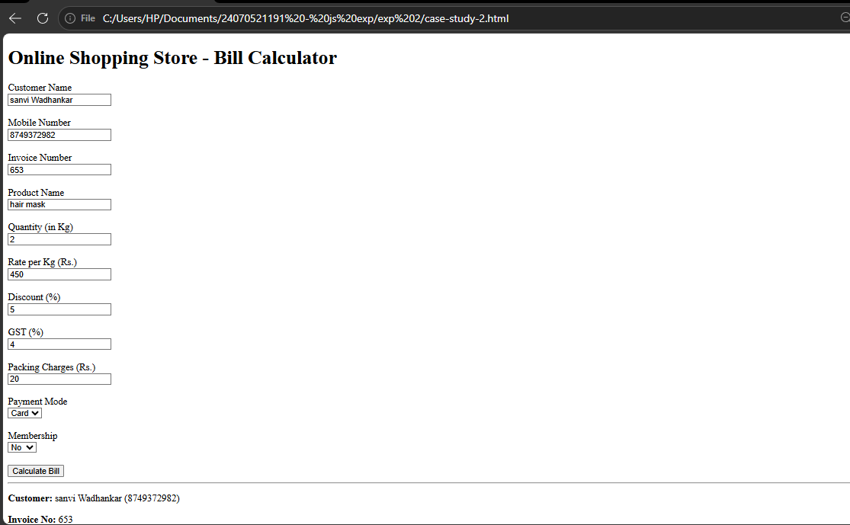
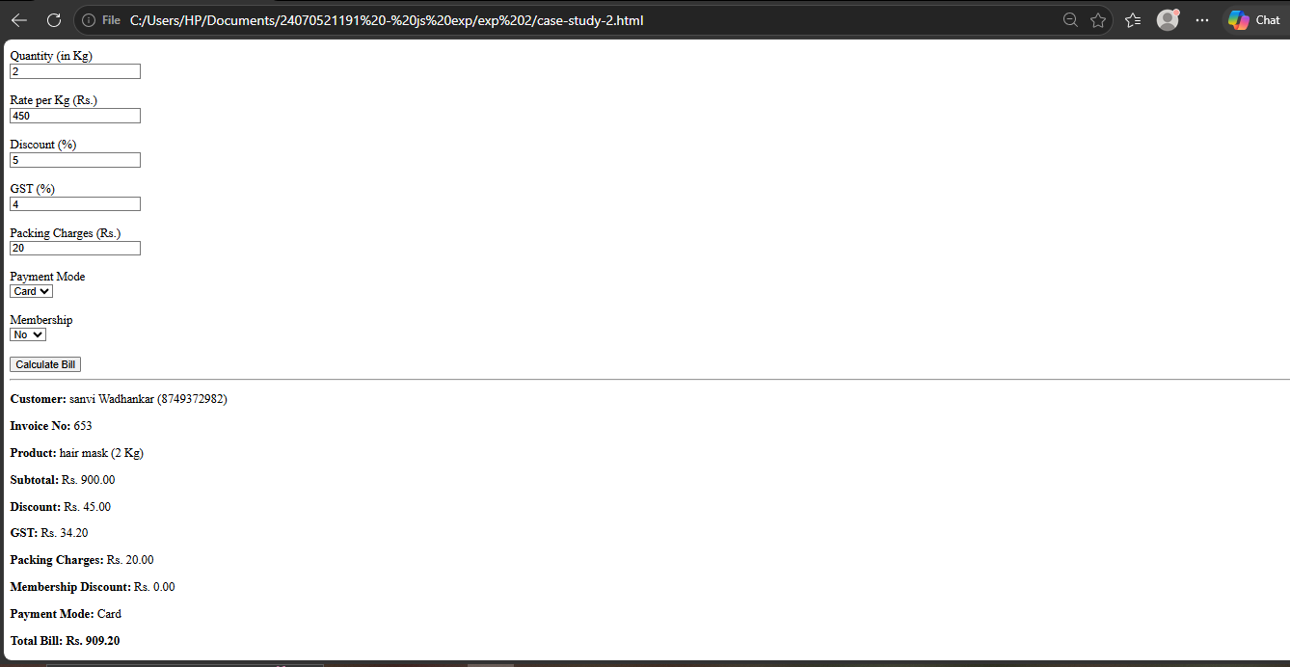

Practical 3
Aim:- Implement control structures and form validation; create a grading system based on user-entered marks.
Software/Tools Required: VS Code , Web Browser
Experiment program code:
Student Marks and grade:-
<html>
<head>
<title>Sanvi Wadhankar</title>
</head>
<body>
<h2>Sanvi wadhankar 1191</h2>
<h2>Student Grading System</h2>
<h3>Enter marks:</h3>
<input type = 'number' id = 'marks'></input>
<button onClick="checkGrade()">Submit</button>
<p id = 'result'></p>
<script>
function checkGrade(){
var marks = document.getElementById("marks").value;
if( marks == ""){
alert("Please Enter marks!!");
return;
}
if(marks<0 || marks> 100){
alert("Enter marks between 0 and 100");
}
if(marks>=90){
grade = 'A';
}
else if(marks >=80){
grade = "B";
}
else if(marks>=70){
grade = "C";
}
else if(marks >=50){
grade = "D"
}
else{

grade = "Fail";
}
document.getElementById("result").innerHTML =
"Marks =" + marks + "<br>Grade = "+ grade;

}
</script>

</body>
</html>

Output:-
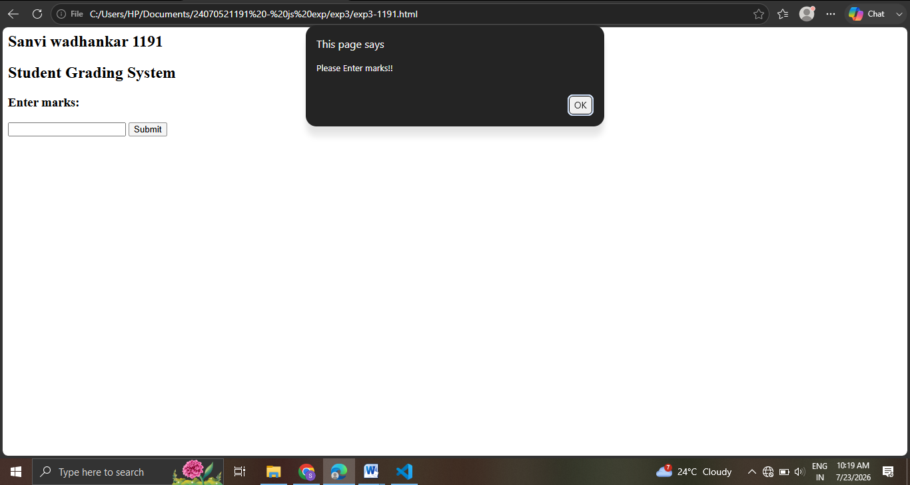
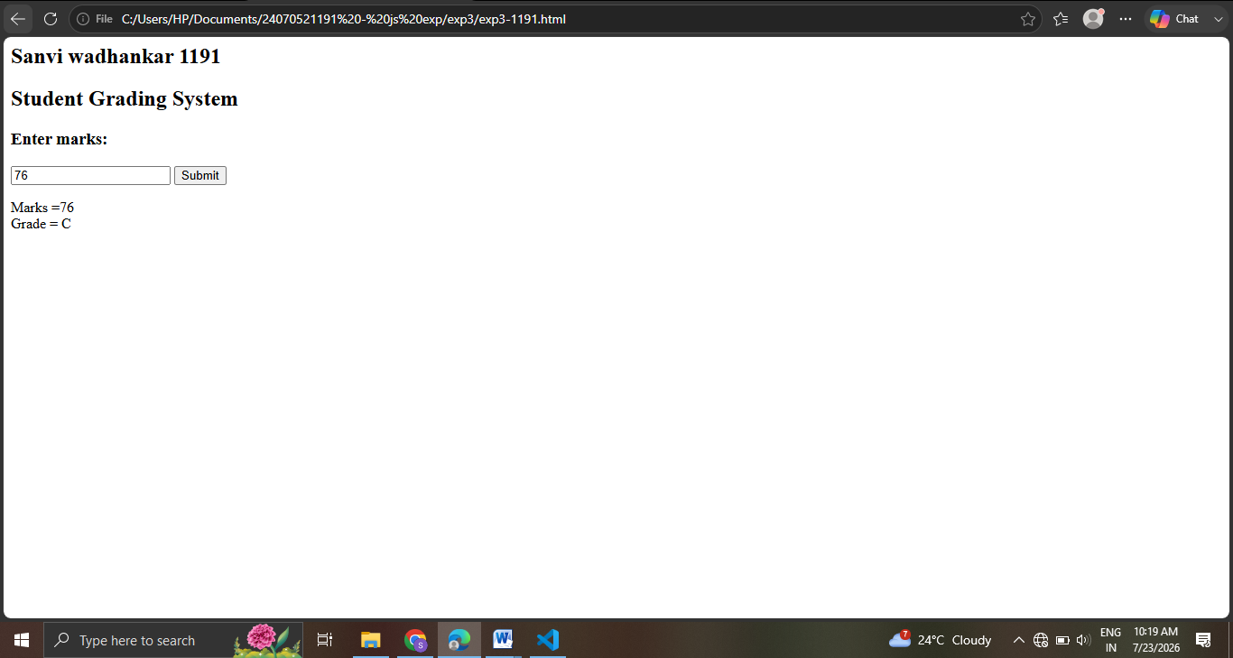
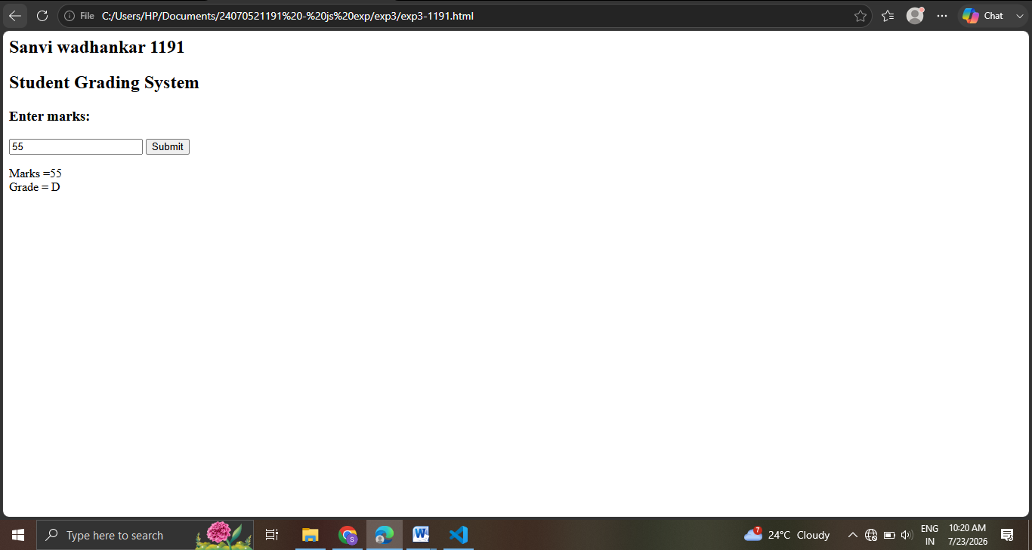
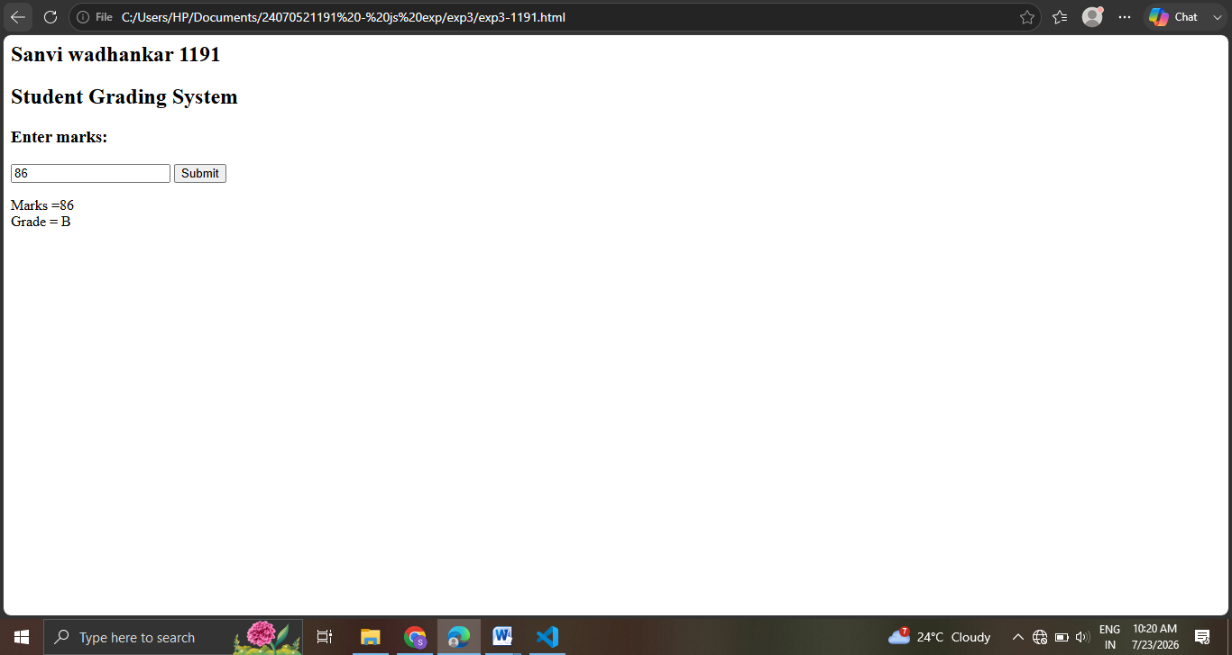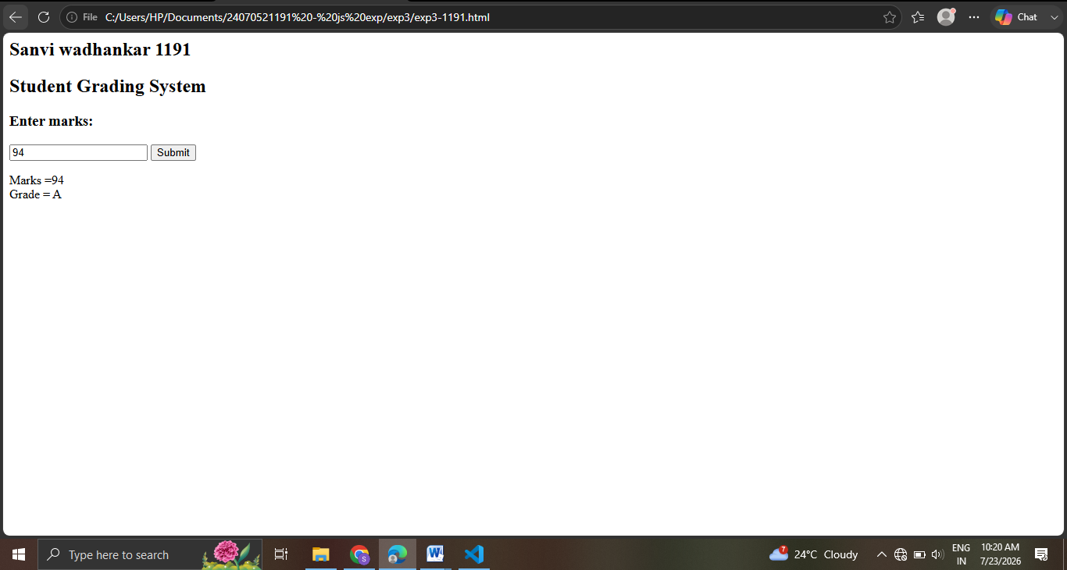

Case Study 03
Case Study Title:- Scholarship Eligibilty:
A college awards scholarship based on marks
Below 50:- Not eligible
50-69:- Bronze Scholarship
70-84:- Silver Scholarship
85-94:- Gold Scholarship
95-100:- Platinum Scholarship
Software/Tools Used:- VScode , Web Browser
Case Study Code:-
<html>
<head>
<title>Scholarship Eligibility</title>
<style>
body {
font-family: Arial, sans-serif;
background-color: #f2f2f2;
text-align: center;
padding: 40px;
}
h2 {
color: #c21321af;
margin: 5px 0;
}
input {
padding: 8px;
font-size: 15px;
margin-top: 10px;
border: 1px solid #c0e61b;
border-radius: 4px;
}
button {
display: block;
margin: 15px auto 0;
padding: 8px 20px;
font-size: 15px;
background-color: #1a5cff;
color: white;
border: none;
border-radius: 4px;
cursor: pointer;
}
button:hover {
background-color: #0d3fb0;
}
#result {
margin-top: 20px;
font-size: 17px;
color: #333;
}
</style>
</head>
<body>
<h2>Sanvi Wadhankar 2407051191</h2>
<h2>Scholarship Eligibility System</h2>
<h3>Enter marks:</h3>
<input type='number' id='marks'></input>
<button onClick="checkScholarship()">Submit</button>
<p id='result'></p>
<script>
function checkScholarship(){
var marks = document.getElementById("marks").value;
if( marks == ""){
alert("Please Enter marks!!");
return;
}
if(marks<0 || marks> 100){
alert("Enter marks between 0 and 100");
return;
}
if(marks>=95){
scholarship = "Platinum Scholarship";
}
else if(marks>=85){
scholarship = "Gold Scholarship";
}
else if(marks>=70){
scholarship = "Silver Scholarship";
}
else if(marks>=50){
scholarship = "Bronze Scholarship";
}
else{
scholarship = "Not Eligible";
}
document.getElementById("result").innerHTML =
"Marks = " + marks + "<br>Scholarship = " + scholarship;
}
</script>
</body>
</html>

Output:-

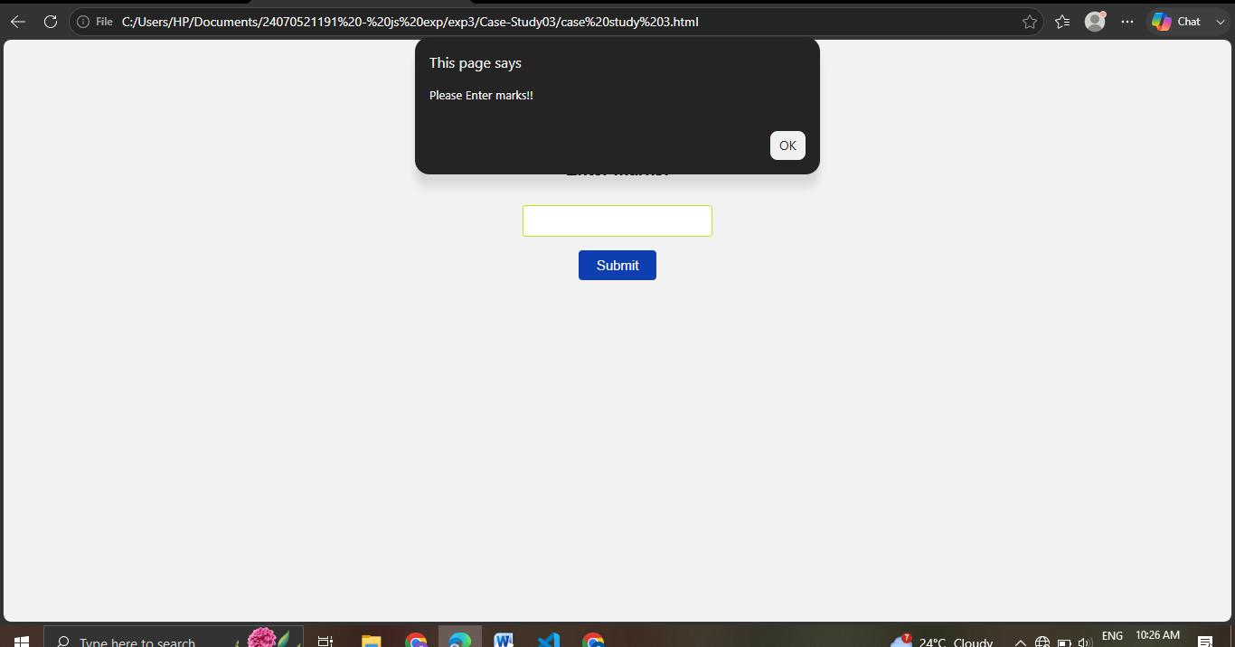
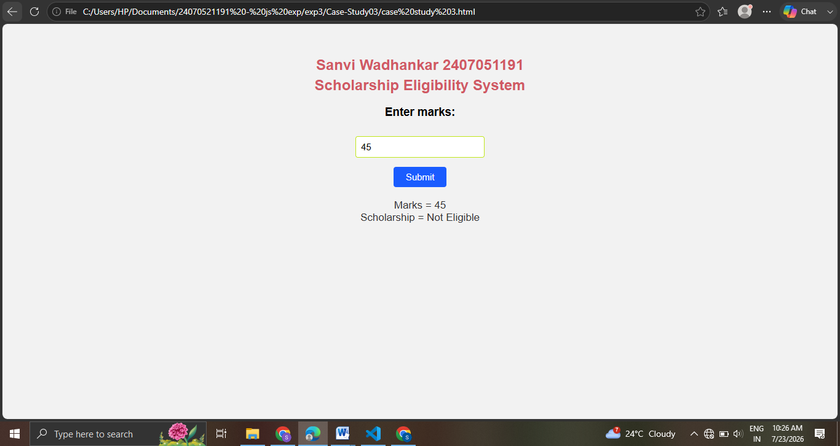
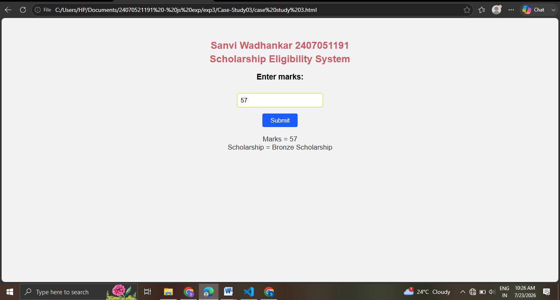
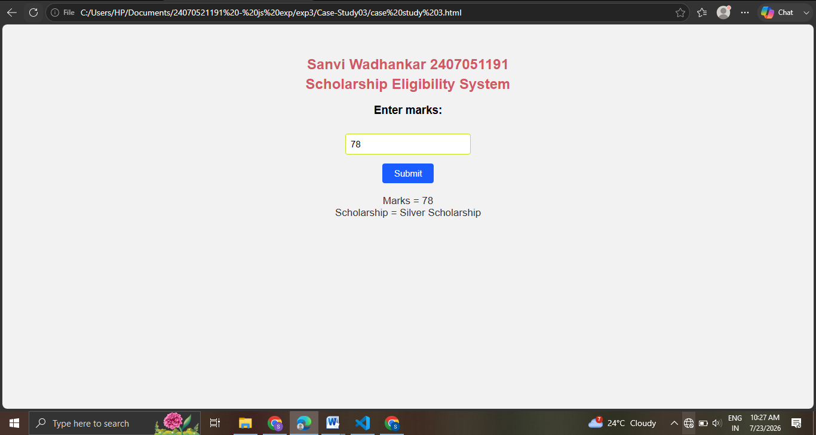
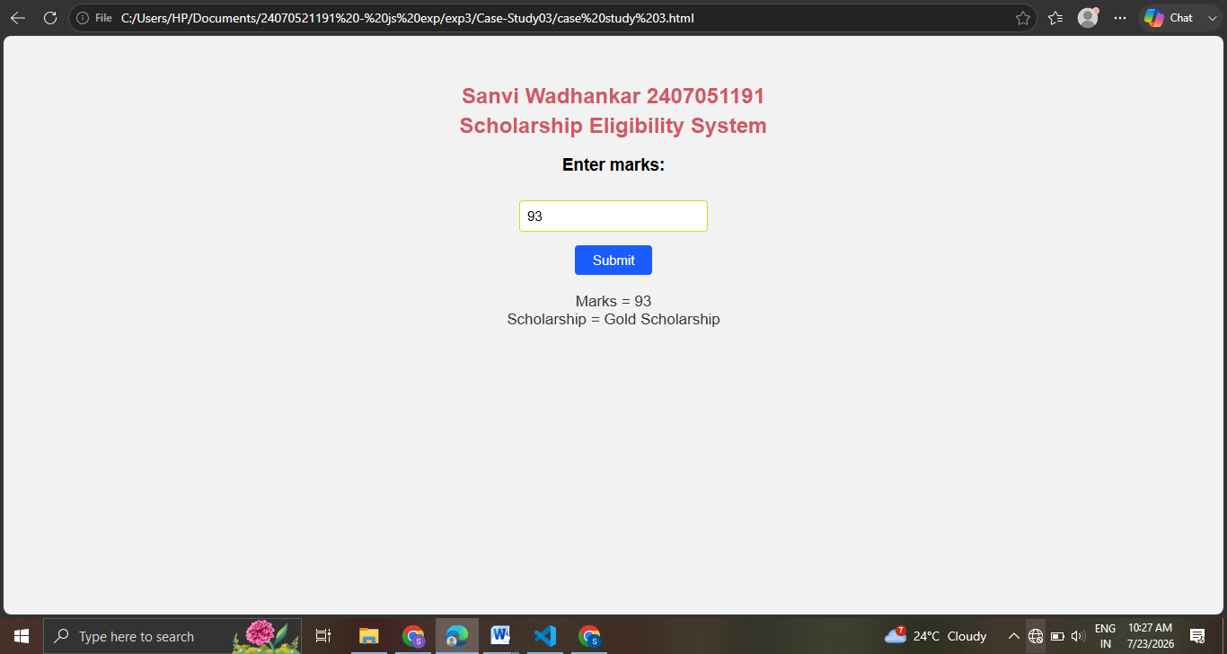
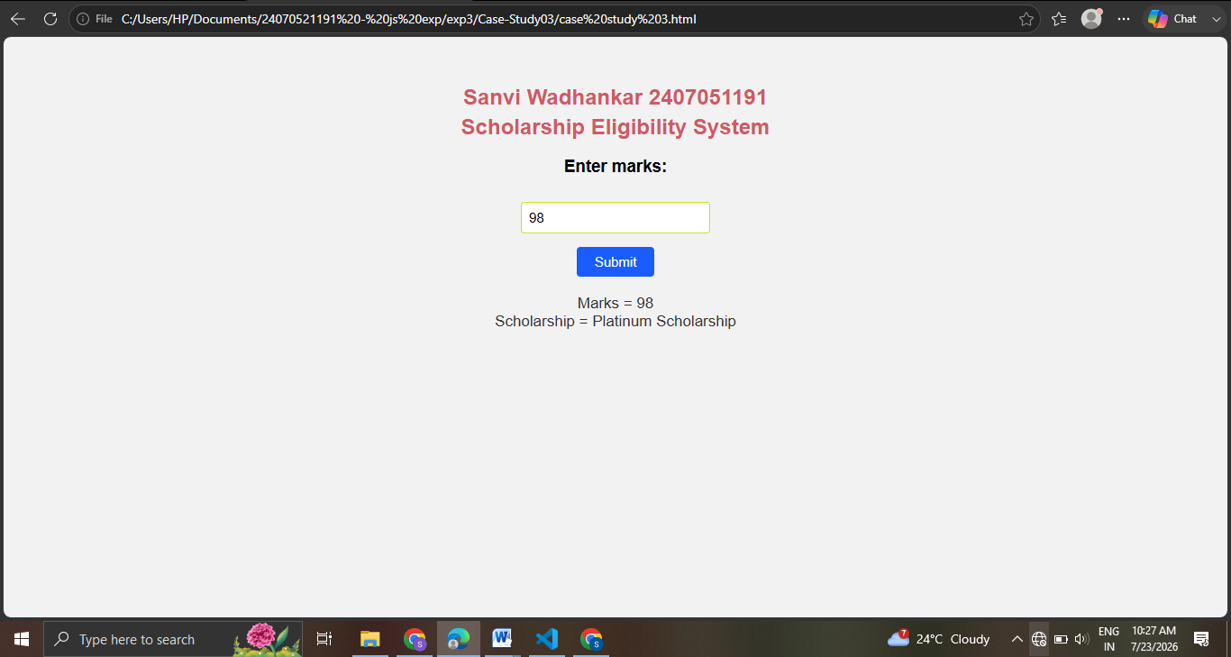
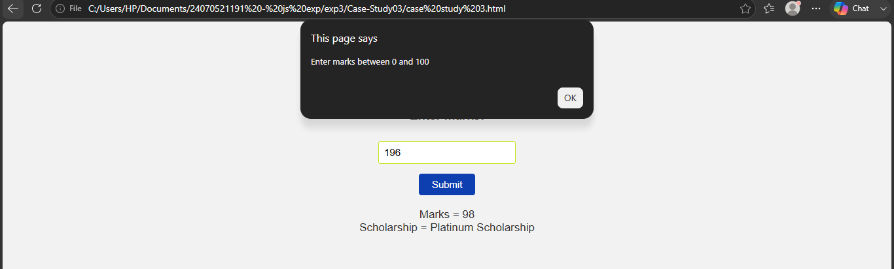

Practical 4
Aim:- Use function types ,scope , and closure; apply try catch ;build a palindrome checker
Software/Tools Required: VS Code , Web Browser
Experiment program code:
Palindrome checker:-
<!DOCTYPE html>
<html lang="en">
<head>
<meta charset="UTF-8">
<meta name="viewport" content="width=device-width, initial-scale=1.0">
<title>Palindrome Checker</title>
<style>
body {
font-family: Arial, sans-serif;
background: #f4f4f4;
text-align: center;
margin-top: 50px;
}
.container {
width: 350px;
margin: auto;
background: white;
padding: 20px;
border-radius: 10px;
box-shadow: 0 0 10px gray;
}
input {
width: 90%;
padding: 10px;
margin: 10px;
}
button {
padding: 10px 20px;
cursor: pointer;
}
h3 {
color: blue;
}
</style>
</head>
<body>

<div class="container">
<h2>Sanvi Wadhankar 24070521191</h2>
<h2>Palindrome Checker</h2>

<input type="text" id="word" placeholder="Enter a word">

<button onclick="checkPalindrome()">Check</button>

<h3 id="result"></h3>
</div>

<script>

// Global Scope
let appName = "Palindrome Checker";

// Function Declaration
function cleanString(str) {
return str.toLowerCase().replace(/[^a-z0-9]/g, "");
}

// Function Expression
const reverseString = function(str) {
return str.split("").reverse().join("");
};

// Closure
function counter() {
let count = 0;

return function() {
count++;
return count;
};
}

const checkCount = counter();

// Arrow Function
const isPalindrome = (str) => {
return str === reverseString(str);
};

// Main Function
function checkPalindrome() {

try {

let input = document.getElementById("word").value;

// Local Scope
let text = cleanString(input);

if (text === "") {
throw "Please enter some text.";
}

let result = isPalindrome(text)
? `"${input}" is a Palindrome ✅`
: `"${input}" is NOT a Palindrome ❌`;

result += `<br>Checks Performed: ${checkCount()}`;

document.getElementById("result").innerHTML = result;

} catch(error) {

document.getElementById("result").innerHTML =
`<span style="color:red;">Error: ${error}</span>`;

}

finally {
console.log(appName + " executed.");
}
}

</script>

</body>
</html>

Output:-
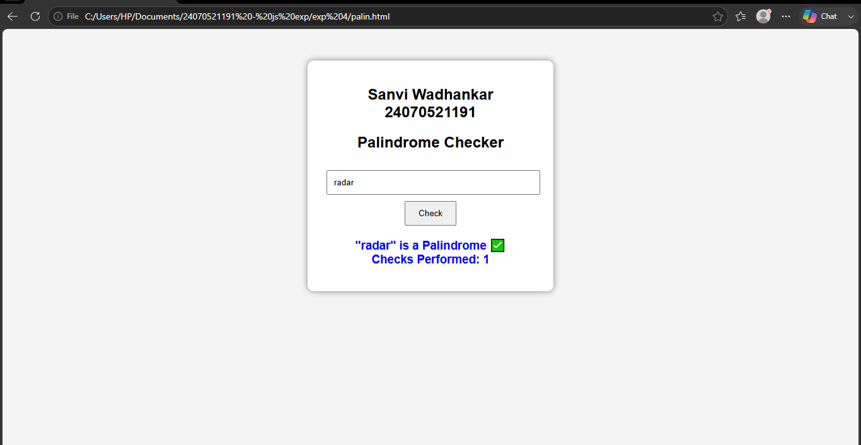
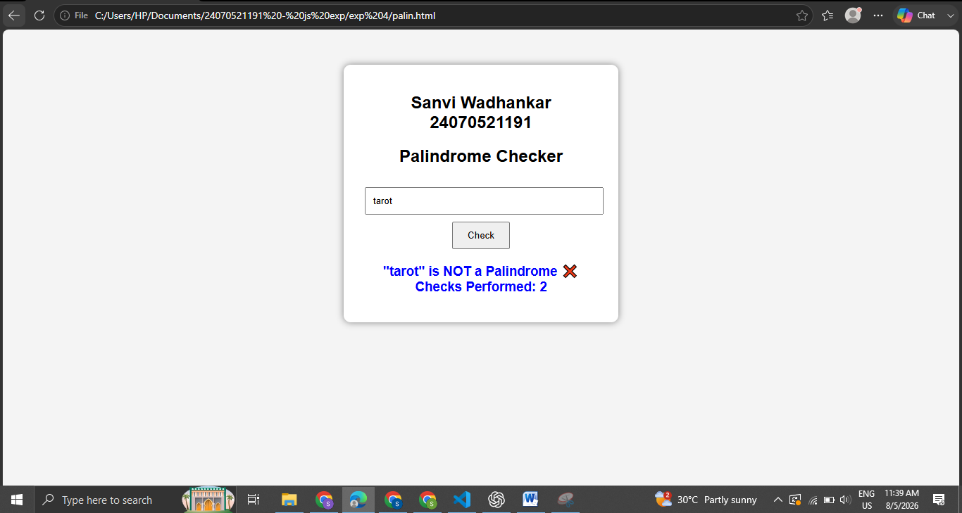
Case Study 04
Real-Time Case Study: ATM Card PIN Verification Using JavaScript Functions
Case Study An ATM system verifies whether a customer's PIN is a palindrome. If the PIN reads the same forward and backward, the bank displays a special security message. To implement this, create a function to reverse the entered PIN number and another function to check whether it is a palindrome. Use function declaration, function expression, arrow function, and demonstrate scope concepts
Software/Tools Used:- VScode , Web Browser
Case Study Code:-
<html>
<head>
<title>ATM PIN Verification</title>
<style>
body {
font-family: Arial, sans-serif;
background-color: #f2f2f2;
text-align: center;
padding: 40px;
}
h2 {
color: #1a5cff;
margin: 5px 0;
}
input {
padding: 8px;
font-size: 15px;
margin-top: 10px;
border: 1px solid #ccc;
border-radius: 4px;
}
button {
display: block;
margin: 15px auto 0;
padding: 8px 20px;
font-size: 15px;
background-color: #1a5cff;
color: white;
border: none;
border-radius: 4px;
cursor: pointer;
}
button:hover {
background-color: #0d3fb0;
}
#result {
margin-top: 20px;
font-size: 17px;
color: #333;
}
</style>
</head>
<body>
<h2>Sanvi Wadhankar 24070521191</h2>
<h2>ATM Card PIN Verification</h2>
<h3>Enter your 6-digit PIN:</h3>
<input type='text' id='pin' maxlength="6"></input>
<button onClick="verifyPin()">Submit</button>
<p id='result'></p>

<script>
// FUNCTION DECLARATION
// Reverses the entered PIN
function reversePin(pin) {
return pin.split("").reverse().join("");
}

// FUNCTION EXPRESSION
// Checks whether the PIN is a palindrome (reads same forward and backward)
var isPalindrome = function(pin) {
var reversed = reversePin(pin); // uses the function declared above
return pin === reversed;
};

// ARROW FUNCTION
// Displays the security message based on the result
var getMessage = (palindromeCheck) => {
if (palindromeCheck) {
return "Security Alert: Your PIN is a palindrome!";
} else {
return "PIN verified. No special security message.";
}
};

// MAIN FUNCTION (called on button click)
// MAIN FUNCTION (called on button click)
function verifyPin() {
var pin = document.getElementById("pin").value; // local scope variable

if (pin == "" || pin.length !== 6 || isNaN(pin)) {
alert("Please enter a valid 6-digit PIN!");
return;
}

var reversed = reversePin(pin);
var palindromeCheck = isPalindrome(pin);
var message = getMessage(palindromeCheck);

// Alert user if the PIN is a palindrome
if (palindromeCheck) {
alert("⚠️ Security Alert!\nYour PIN is a palindrome.\nFor better security, please change your ATM PIN.");
}

document.getElementById("result").innerHTML =
"PIN entered = " + pin + "<br>" +
"Reversed PIN = " + reversed + "<br>" +
message;
}
</script>
</body>
</html>

Output:-
